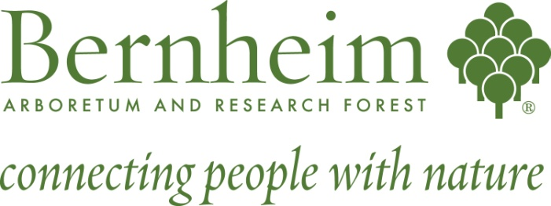
Bernheim Natural Areas Internship
SITE SUPERVISOR: Forest Manager, Andrew Berry

REPORTS: Forest Manager

PROJECT SUMMARY
Bernheim Natural Areas Intern Program is open to all students with a passion for stewardship of natural areas. Preference is given to applicants with an interest in pursuing a career in ecology, biology, wildlife management, botany, or related disciplines. Our interns gain hands on work experience in ecological stewardship both in Bernheim and in the surrounding community, create opportunities to connect and exchange ideas with professionals in their field, and leave with a sense of understanding of the workings of a dynamic non-profit institution that connects people with nature.
DUTIES
Interns will work with Bernheim staff assisting with restoration and management of the 14,670 acre Bernheim Forest. Duties include, but are not limited to, assisting in wildlife restoration and monitoring projects, invasive exotic species removal projects, maintenance and monitoring of ongoing restoration projects, threatened and endangered species monitoring and management, GPS/GIS mapping, and assisting with Bernheim events or programming. Field trips, workshops, and seminars are offered when available.
KNOWLEDGE, TRAINING & SKILLS
To perform this job successfully an individual must be able to perform each essential duty satisfactorily. The requirements listed below are representative of the knowledge, skill, and/or ability required. Reasonable accommodations may be made to enable individuals with disabilities to perform the essential functions. Lack of experience may be substituted with education and a strong willingness to learn. 1) An understanding of ecosystem processes and land management principles. Interns should be committed to practicing responsible and effective land stewardship. 2) Ability to communicate, work, live, and function effectively within a team of interns. 3) Familiarity with operation and use of vehicle with standard transmissions, herbicide spray tanks, chippers, chainsaws, string trimmers, leaf blowers and hand tools. 4) Ability to work with minimal supervision in remote areas in proximity to wildlife. This position involves traversing difficult terrain, ticks, chiggers, and oftentimes wet feet. Good boots are essential.
Internship Timeline and Required Hours/Work Schedule
40 hours a week/ 12 week duration
Start and end dates negotiable
Deadline to apply:
No deadline, we are always looking for good applicants.
For application, please click on link located on our webpage:
Send completed applications to Lorie Messer: lmesser@bernheim.org

