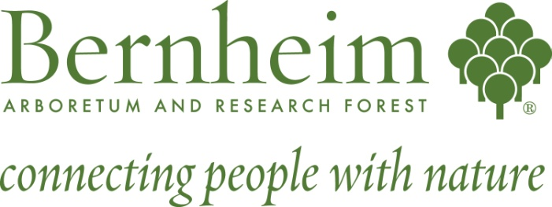

Horticulture Internship

Project Summary:
Bernheim is the Official Arboretum of Kentucky and contains a diverse collection of woody plants that includes some 6,000 accessioned trees and shrubs displayed in a landscape setting of over 300 acres. Signature collections include important genera such as: Ilex, Cornus, Acer, Quercus, Magnolia, and Malus; conifers, and native habitat display areas.
Bernheim’s Horticulture Internship seeks candidates to help share in our mission: “Bernheim will be a nationally treasured leader in ecological stewardship that inspires the exploration of our deep connections with nature.” Our approach in Horticultural practices are rooted in the idea that all landscapes, natural or created, should coexist to compliment and benefit one another through thoughtful planning and sustainable maintenance initiatives. Bernheim strives to research new and innovative strategies in dealing with common landscape issues and welcomes our interns to contribute towards our goal of providing visitors with an educationally informative, ecologically friendly, and peaceful experience within our Arboretum. Horticulture internships insure that our aspirations, ideas, and objectives are shared within the greater community, other institutions, and throughout the region.
Duties and Activities:
Responsibilities include assisting Bernheim staff and volunteers with collections and grounds maintenance, edible garden production and maintenance, nursery and greenhouse production, and educational program development. Duties include, but are not limited to: planting, weeding, string trimming, pruning, mulching, watering, propagating plants, assisting in invasive exotic species removal, participating in plant evaluations and other research projects. Interns will contribute to blogs and write research summaries as required. Field trips and seminars will be offered when available.
Post Internship Deliverables:
Students will have the opportunity to develop a project based upon the needs of the Horticulture team and personal interest, which benefit the greater goals of Bernheim, to be completed by the end of the Internship period. Possibilities may include landscape design, propagation, program development, plant records accession and cataloguing, or a comprehensive presentation.

Recommended Background:
Bernheim’s Horticulture intern program is open to all students who study horticulture, landscape architecture, botany, forestry, conservation biology, environmental sciences or related disciplines and who are willing to advance their knowledge through practical hands on experience. Bernheim seeks reliable and hard-working candidates who thrive in a team setting and are also capable of completing individual tasks as assigned.
Required background or skills:
Applicants must possess an interest in arboretum collections management and conservation horticulture. Ideal candidates will have basic plant identification skills and be familiar with the operation and use of vehicles, irrigation equipment, rototillers, chainsaws, string trimmers, leaf blowers and hand tools. Position may involve some use of herbicides, performing physically demanding work in various weather conditions and working around poison ivy, stinging insects, ticks, snakes, mud and brush. Interns must be in good physical condition and able to lift 40 pounds.
Lodging: Lodging is provided
Begin Date: May, negotiable
End Date: August, negotiable
Duration (weeks): 9 to 12 weeks
Hours per week: 40
Reports To: Horticulture Staff
Application is available online on our Website: bernheim.org under the employment section.
Please mail or e-mail cover sheet and resume to: Bernheim Forest, Attn: Lorie Messer, Human Resource Dept. P.O.Box 130, Clermont KY, 40110
E-mail address: lmesser@bernheim.org

